# Objectives

In this section, the goals in this laboratory are:

* To create a Python program that use selection widget like Combobox
* To use ttk function as part of Tk ( ) in the Tkinter module

# Methods

General Instructions:

* Copy these Python codes into your PyCharm and save it as test.py

import tkinter as tk

from tkinter import ttk

from tkinter import messagebox

from tkinter.messagebox import showinfo

# Creating tkinter window and set dimensions

window = tk.Tk()

window.title('Combobox')

window.geometry('500x250')

def choice(event):

month = event.widget.get()

print("Your birth month", month)

# label text for title

ttk.Label(window, text="Choose your birth month",

background='light yellow', foreground="black",

font=("Times New Roman", 15)).grid(row=0, column=1)

# Set label

ttk.Label(window, text="Select the month of your birth :",

font=("Times New Roman", 12)).grid(column=0,

row=5, padx=5, pady=25)

# Create Combobox

n = tk.StringVar()

month = ttk.Combobox(window, width=27, textvariable=n)

# Adding combobox drop down list

month['values'] = (' January',

' February',

' March',

' April',

' May',

' June',

' July',

' August',

'September',

'October',

'November',

'December')

month.grid(column=1, row=5)

month.current()

def choice(event):

showinfo(

title = "Selection",

message = f'You selected{n.get()}')

month.bind("<<ComboboxSelected>>", choice)

window.mainloop()

# Results

*Present the visualized procedures done. Also present the results with corresponding data visualizations such as graphs, charts, or screenshot of the output. Please provide insights, commentaries, or explanations regarding the data. If an explanation requires the support of literature such as academic journals, books, magazines, reports, or web articles please cite and reference them using the IEEE format.*

*Please take note of the styles on the style ribbon as these would serve as the style format of this laboratory report. The body style is Times New Roman size 12, line spacing: 1.5. Body text should be in Justified alignment, while captions should be center-aligned. Images should be readable and include captions. Please refer to the sample below:*

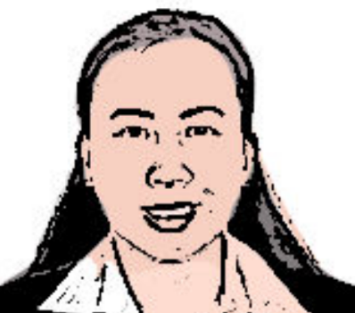

Figure 2. A cheerful professor

If an image is taken from another literature or intellectual property, please cite them accordingly in the caption. Always keep in mind the Honor Code [1] of our course to prevent failure due to academic dishonesty.

# Conclusion

*The conclusion expresses the summary of the whole laboratory report as perceived by the authors of the report.*

**Reference**

Book

[1]

Website

[2]